**Experiment No.: 1**

**Aim**

Define a class ‘product’ with data members pcode, pname and price. Create 3 objects of the class and find the product having the lowest price.

**CO1**

Understand object-oriented concepts and design classes and objects to solve problems.

**Procedure**

import java.util.*;

public class Product

{

int pcode;

String pname;

int price;

public void get()

{

Scanner sc = new Scanner(System.in);

System.out.println("Enter the pcode : ");

pcode = sc.nextInt();

System.out.println("Enter the pname : ");

pname = sc.next();

System.out.println("Enter the price : ");

price = sc.nextInt();

}

public void print()

{

System.out.println("Product details are : ");

System.out.println("pcode : "+pcode);

System.out.println("pname : "+pname);

System.out.println("price : "+price);

}

public static void main(String args[])

{

Product p1 = new Product();

p1.get();

p1.print();

Product p2 = new Product();

p2.get();

p2.print();

Product p3 = new Product();

p3.get();

p3.print();

if((p1.price < p2.price) && (p1.price < p3.price))

{

System.out.println("Least price product : "+p1.pname);

System.out.println("price : "+p1.price);

}

else if((p2.price < p1.price)&&(p2.price < p3.price))

{

System.out.println("Least price product : "+p2.pname);

System.out.println("price : "+p2.price);

}

else

{

System.out.println("Least price product : "+p3.pname);

System.out.println("price : "+p3.price);

}

}

}

**Output Screenshot**

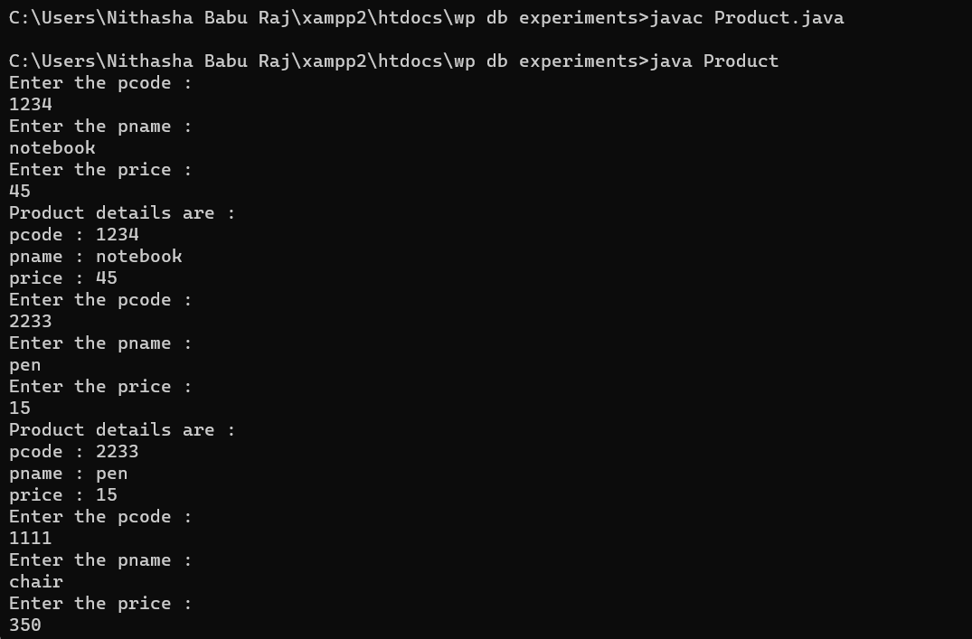

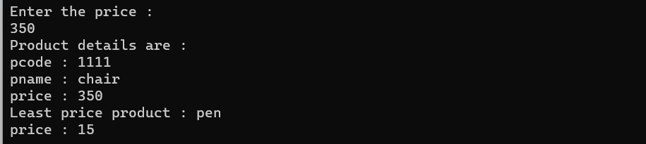

**Result**

The program was executed and the result was successfully obtained. Thus CO1 was obtained.

**Experiment No.: 2**

**Aim**

Read 2 matrices from the console and perform matrix addition.

**CO1**

Understand object-oriented concepts and design classes and objects to solve problems.

**Procedure**

import java.util.*;

public class MatrixAdd

{

public static void main(String args[])

{

Scanner in = new Scanner(System.in);

System.out.println("Enter the no:of rows in matrix 1 :");

int r1 = in.nextInt();

System.out.println("Enter the no:of columns in matrix 1:");

int c1 = in.nextInt();

int mat1[][] = new int[r1][c1];

System.out.println("Enter the no:of rows in matrix 2 :");

int r2 = in.nextInt();

System.out.println("Enter the no:of columns in matrix 2:");

int c2 = in.nextInt();

int mat2[][] = new int[r2][c2];

int mat3[][] = new int[r2][c2];

System.out.println("Enter the matrix 1 elements : ");

for(int i=0;i<r1;i++)

{

for(int j=0;j<c1;j++)

{

mat1[i][j]=in.nextInt();

}

}

System.out.println("Matrix 1 elements : ");

for(int i=0;i<r1;i++)

{

for(int j=0;j<c1;j++)

{

System.out.print(mat1[i][j]);

System.out.print("\t");

}

System.out.print("\n");

}

System.out.println("Enter the matrix 2 elements : ");

for(int i=0;i<r2;i++)

{

for(int j=0;j<c2;j++)

{

mat2[i][j]=in.nextInt();

}

}

System.out.println("Matrix 2 elements : ");

for(int i=0;i<r2;i++)

{

for(int j=0;j<c2;j++)

{

System.out.print(mat2[i][j]);

System.out.print("\t");

}

System.out.print("\n");

}

System.out.println("Adding 2 matrices....\n");

for(int i=0;i<r2;i++)

{

for(int j=0;j<c2;j++)

{

mat3[i][j]=mat1[i][j]+mat2[i][j];

}

}

System.out.println("Sum of matrix 1 and matrix 2 is :");

for(int i=0;i<r2;i++)

{

for(int j=0;j<c2;j++)

{

System.out.print(mat3[i][j]);

System.out.print("\t");

}

System.out.print("\n");

}

}

}

**Output Screenshot**

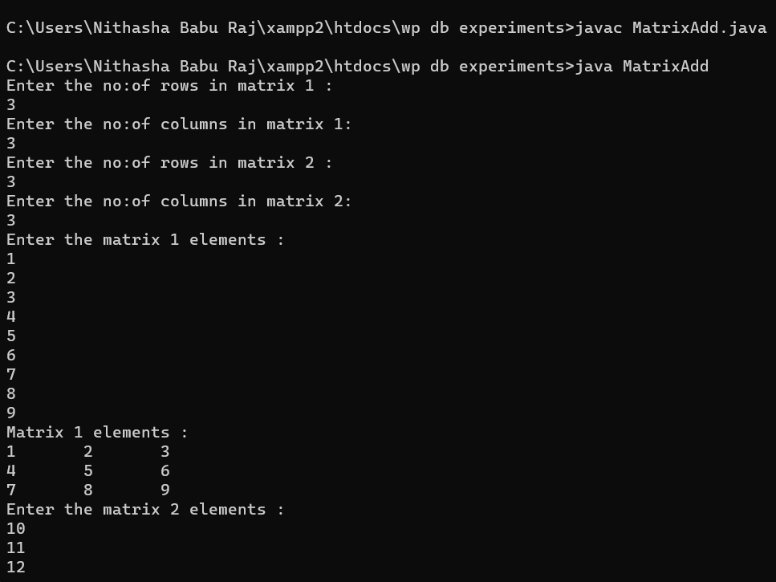

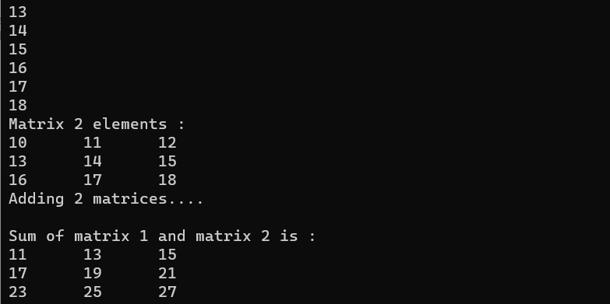

**Result**

The program was executed and the result was successfully obtained. Thus CO1 was obtained.

**Experiment No.: 3**

**Aim**

Add complex numbers

**CO1**

Understand object-oriented concepts and design classes and objects to solve problems.

**Procedure**

import java.util.*;

public class Complex

{

public static void main(String args[])

{

Scanner sc = new Scanner(System.in);

System.out.println("Enter the real part of 1st complex number : ");

int r1 = sc.nextInt();

System.out.println("Enter the imaginary part of 1st complex number : ");

int i1 = sc.nextInt();

System.out.println("Enter the real part of 2nd complex number : ");

int r2 = sc.nextInt();

System.out.println("Enter the imaginary part of 2nd complex number : ");

int i2 = sc.nextInt();

System.out.println("1st Complex Number : "+r1+"+"+i1+"i");

System.out.println("2nd Complex Number : "+r2+"+"+i2+"i");

System.out.println("Adding 2 complex numbers : "+(r1+r2)+"+"+(i1+i2)+"i");

}

}

**Output Screenshot**

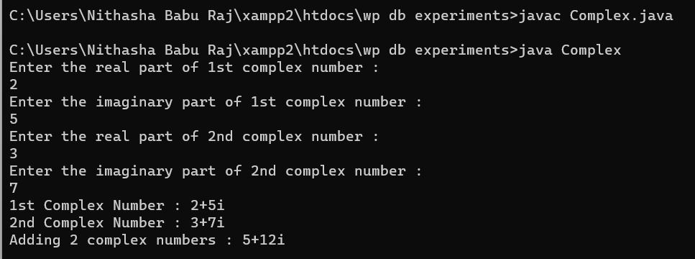

**Result**

The program was executed and the result was successfully obtained. Thus CO1 was obtained.

**Experiment No.: 4**

**Aim**

Read a matrix from the console and check whether it is symmetric or not.

**CO1**

Understand object-oriented concepts and design classes and objects to solve problems.

**Procedure**

import java.util.*;

public class MatrixSymm

{

public static void main(String args[])

{

int count=0;

Scanner in = new Scanner(System.in);

System.out.println("Enter the no:of rows in matrix :");

int r = in.nextInt();

System.out.println("Enter the no:of columns in matrix :");

int c = in.nextInt();

int mat1[][] = new int[r][c];

int mat2[][] = new int[r][c];

System.out.println("Enter the matrix 1 elements : ");

for(int i=0;i<r;i++)

{

for(int j=0;j<c;j++)

{

mat1[i][j]=in.nextInt();

}

}

System.out.println("Matrix 1 elements : ");

for(int i=0;i<r;i++)

{

for(int j=0;j<c;j++)

{

System.out.print(mat1[i][j]);

System.out.print("\t");

}

System.out.print("\n");

}

for(int i=0;i<r;i++)

{

for(int j=0;j<c;j++)

{

mat2[i][j]=mat1[j][i];

}

}

System.out.println("Transpose of Matrix 1 : ");

for(int i=0;i<r;i++)

{

for(int j=0;j<c;j++)

{

System.out.print(mat2[i][j]);

System.out.print("\t");

}

System.out.print("\n");

}

for(int i=0;i<r;i++)

{

for(int j=0;j<c;j++)

{

if(mat2[i][j]==mat1[i][j])

{

count++;

}

}

}

if(count==r*c)

{

System.out.println("Matrix 1 is symmetric");

}

else

{

System.out.println("Matrix 1 is not symmetric");

}

}

}

**Output Screenshot**

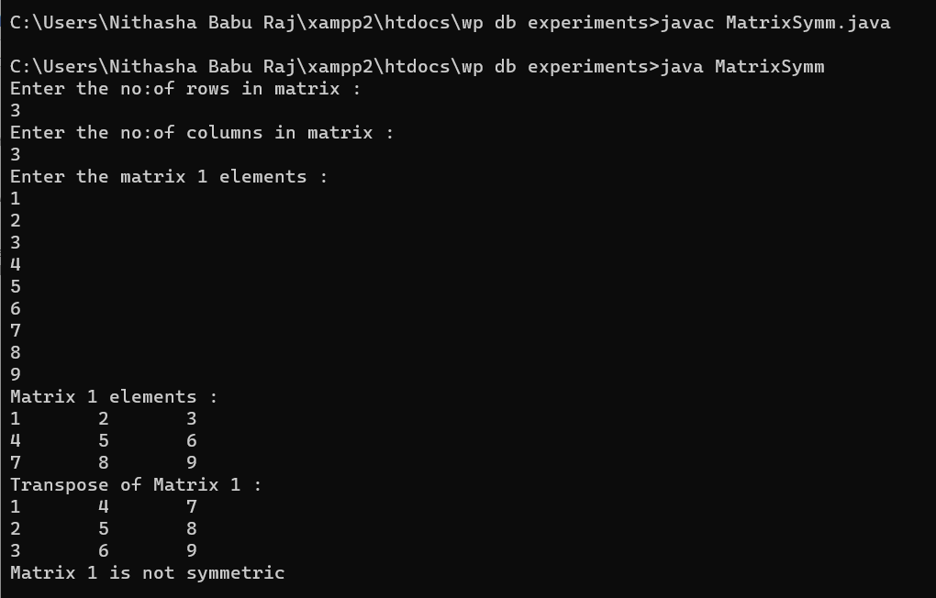

**Result**

The program was executed and the result was successfully obtained. Thus CO1 was obtained.

**Experiment No.: 5**

**Aim**

Program to Sort strings

**CO2**

Implement arrays and strings

**Procedure**

import java.util.*;

public class SortStr

{

public static void main(String args[])

{

Scanner sc = new Scanner(System.in);

System.out.println("Enter the limit : ");

int n = sc.nextInt();

String arr[] = new String[n];

System.out.println("Enter the array elements : ");

for(int i=0;i<n;i++)

{

arr[i]=sc.next();

}

for(int i=0;i<n;i++)

{

for(int j=i+1;j<n;j++)

{

if(arr[i].compareTo(arr[j])>0)

{

String temp=arr[i];

arr[i]=arr[j];

arr[j]=temp;

}

}

}

System.out.println("Sorted array elements are : ");

for(int i=0;i<n;i++)

{

System.out.println(arr[i]);

}

}

}

**Output Screenshot**

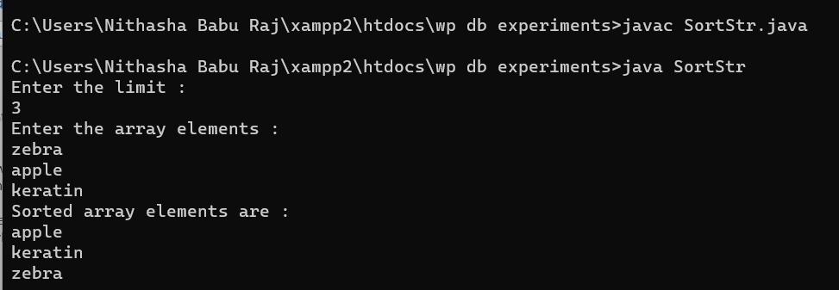

**Result**

The program was executed and the result was successfully obtained. Thus CO2 was obtained.

**Experiment No.: 6**

**Aim**

Search an element in an array.

**CO2**

Implement arrays and strings

**Procedure**

import java.util.*;

public class Array

{

public static void main(String args[])

{

Scanner sc = new Scanner(System.in);

System.out.println("Enter the size of array : ");

int n = sc.nextInt();

int a[] = new int[n];

int flag=0;

System.out.println("Enter the array elements : ");

for(int i=0;i<n;i++)

{

a[i] = sc.nextInt();

}

System.out.println("Array elements are : ");

for(int i=0;i<n;i++)

{

System.out.print(" "+a[i]);

}

System.out.println("\nEnter the element to be searched : ");

int s = sc.nextInt();

for(int i=0;i<n;i++)

{

if(a[i]==s)

{

flag=1;

System.out.println("\nElement "+s+" found at location "+(i+1));

break;

}

}

if(flag==0)

{

System.out.println("Element "+s+" not found ");

}

}

}

**Output Screenshot**

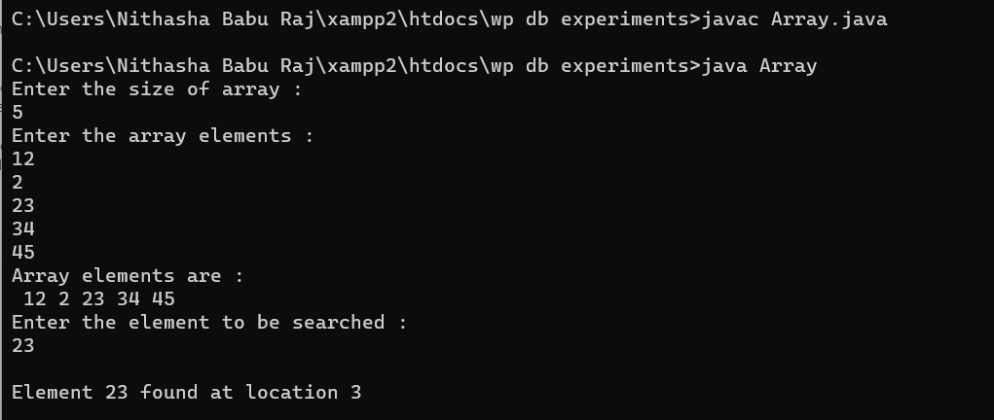

**Result**

The program was executed and the result was successfully obtained. Thus CO2 was obtained.

**Experiment No.: 7**

**Aim**

Perform string manipulations

**CO2**

Implement arrays and strings

### Procedure

import java.util.Scanner;

import java.lang.*;

public class Manipulations

{

public static void main(String [] args)

{

int a;

String b,c;

Scanner sc = new Scanner(System.in);

System.out.print(" Enter the string : ");

b = sc.nextLine();

while(true)

{

System.out.println("MENU: 1.String Length. 2.Uppercase. 3.Lowercase. 4. StringConcatenate. 5.Character index. 6.Exit.");

System.out.print("\n Enter your option : ");

a = sc.nextInt();

switch(a)

{

case 1: System.out.println(" String length = "+b.length());

break;

case 2: System.out.println(" String in uppercase = "+b.toUpperCase());

break;

case 3: System.out.println(" String in lowercase = "+b.toLowerCase());

break;

case 4: System.out.print(" Enter the string to be concatenate = ");

c = sc.next();

System.out.println(" Concatenated string = "+b.concat(c));

break;

case 5: System.out.print(" Enter the Character to be searched in the given string = ");

c = sc.next();

System.out.println(" The character is found at "+(b.indexOf(c)+1)+".");

break;

case 6: System.exit(0);

}

}

}

}

### Output Screenshot

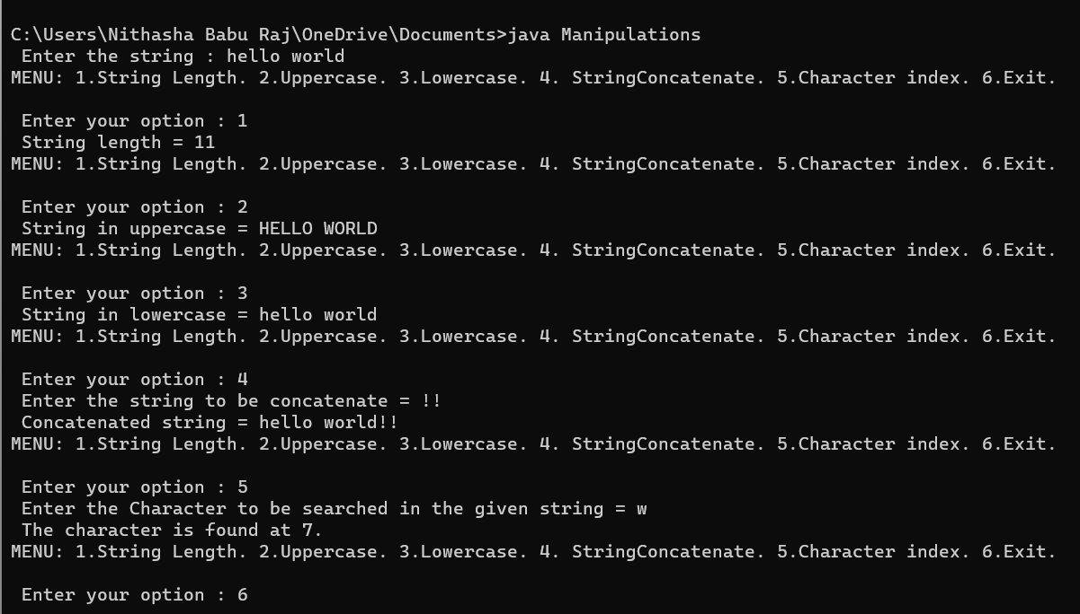

**Result**

The program was executed and the result was successfully obtained. Thus CO2 was obtained.

**Experiment No.: 8**

**Aim**

### Program to create a class for Employee having attributes eNo, eName eSalary. Read n employ information and Search for an employee given eNo, using the concept of Array of Objects.

**CO2**

Implement arrays and strings

### Procedure

import java.util.*;

public class Employee

{

int eNo;

String eName;

int eSal;

public void get()

{

Scanner sc = new Scanner(System.in);

System.out.println("Enter the Eno : ");

eNo = sc.nextInt();

System.out.println("Enter the Ename : ");

eName = sc.next();

System.out.println("Enter the Esalary : ");

eSal = sc.nextInt();

}

public void print()

{

System.out.println("Eno : "+eNo);

System.out.println("Ename : "+eName);

System.out.println("Esalary : "+eSal);

}

public static void main(String args[])

{

int flag=0;

Scanner sc = new Scanner(System.in);

System.out.println("Enter the limit : ");

int n = sc.nextInt();

Employee e[] = new Employee[n];

for(int i=0;i<n;i++)

{

e[i]=new Employee();

e[i].get();

}

System.out.println("Employee details are : ");

for(int i=0;i<n;i++)

{

e[i].print();

}

System.out.println("Enter the Eno to search the employee : ");

int s = sc.nextInt();

for(int i=0;i<n;i++)

{

if(e[i].eNo==s)

{

System.out.println("Searched employee details : ");

e[i].print();

flag=1;

break;

}

else

{

flag=0;

}

}

if(flag==0)

{

System.out.println("Employee with eno : "+s+" not found");

}

}

}

z

### Output Screenshot

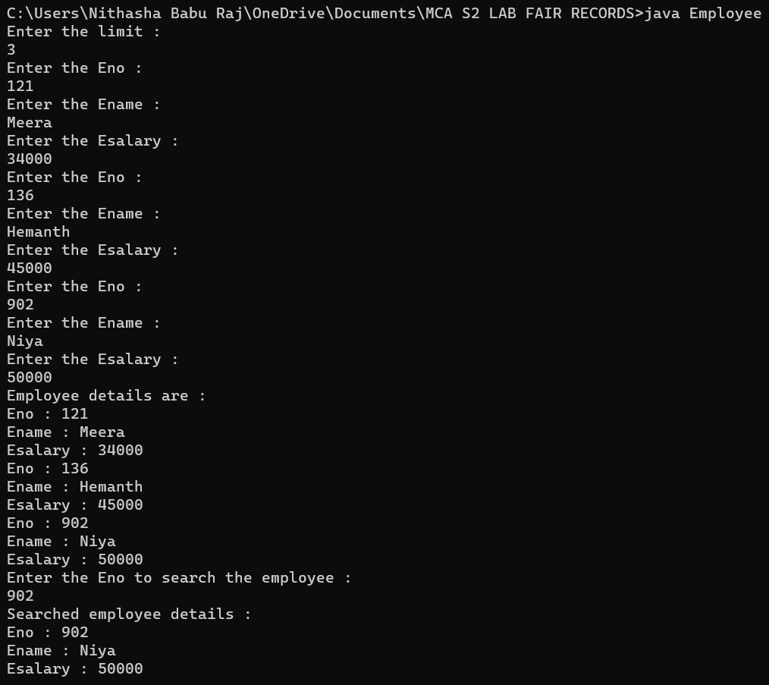

**Result**

The program was executed and the result was successfully obtained. Thus CO2 was obtained.

**Experiment No.: 9**

**Aim**

Area of different shapes using overloaded functions

**CO3**

Implement object-oriented concepts like inheritance, overloading and interfaces

**Procedure**

import java.util.*;

public class Shape

{

int d,ba1;

double e,c;

float a,b,f,ht1;

public void area(float r)

{

a=r;

float area = (3.14f)*(a*a);

System.out.println("Area of circle : "+area);

}

public void area(double b,double h)

{

e=b;

c=h;

double area = 0.5*(e*c);

System.out.println("Area of triangle : "+area);

}

public void area(int a)

{

d=a;

int area = d*d;

System.out.println("Area of square : "+area);

}

public void area(float l,float w)

{

float b = l;

float f = w;

float area = b*f;

System.out.println("Area of rectangle : "+area);

}

public void area(int ba,float ht)

{

int ba1 = ba;

float ht1 = ht;

float area = ba1*ht1;

System.out.println("Area of Parallelogram : "+area);

}

public void area(double s1,double s2,double h1)

{

double sd1 = s1;

double sd2 = s2;

double ht2 = h1;

double area = 0.5*(sd1+sd2)*ht2;

System.out.println("Area of Trapezium : "+area);

}

public void area(int m1,double m2)

{

int mj = m1;

double mi = m2;

double area = (3.14*mi*mj);

System.out.println("Area of Trapezium : "+area);

}

public static void main(String args[])

{

int a,c,ba,m1;

double b,h,m2,s1,s2,h1;

float r,l,w,d,ht;

Shape s = new Shape();

Scanner in = new Scanner(System.in);

System.out.println("Enter the radius to calculate area of circle : ");

r = in.nextFloat();

s.area(r);

System.out.println("Enter the base and height to calculate area of triangle : ");

b = in.nextDouble();

h = in.nextDouble();

s.area(b,h);

System.out.println("Enter the side to calculate area of square : ");

a = in.nextInt();

s.area(a);

System.out.println("Enter the length and breadth to calculate area of rectangle : ");

l = in.nextFloat();

w = in.nextFloat();

s.area(l,w);

System.out.println("Enter the base and height to calculate area of parallelogram : ");

ba = in.nextInt();

ht = in.nextFloat();

s.area(ba,ht);

System.out.println("Enter 2 sides and height to calculate area of trapezium : ");

s1 = in.nextDouble();

s2 = in.nextDouble();

h1 = in.nextDouble();

s.area(s1,s2,h1);

System.out.println("Enter 2 sides  to calculate area of ellipse : ");

m1 = in.nextInt();

m2 = in.nextDouble();

s.area(m1,m2);

}

}

### Output Screenshot

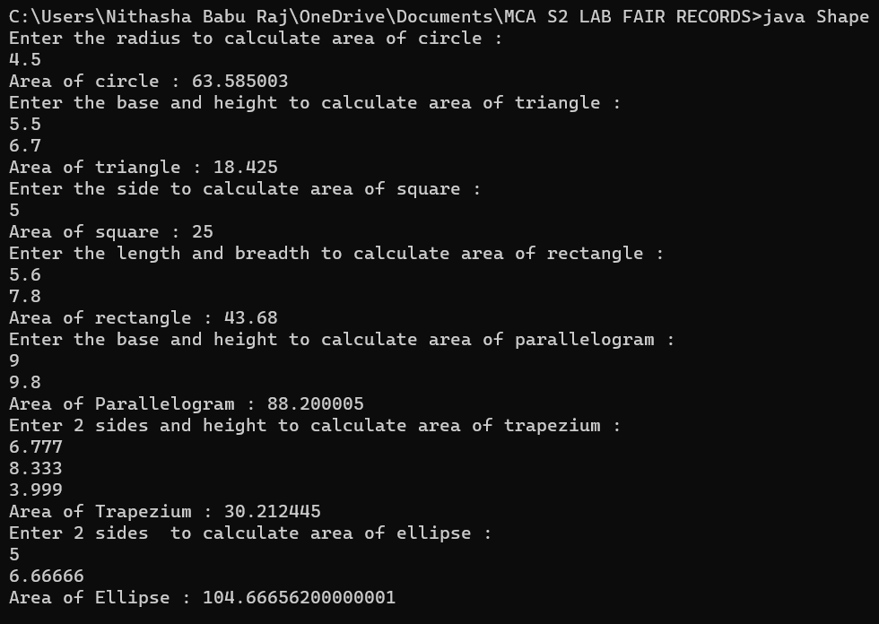

**Result**

The program was executed and the result was successfully obtained. Thus CO3 was obtained.

**Experiment No.: 10**

**Aim**

Create a class ‘Employee’ with data members Empid, Name, Salary, Address and constructors to initialize the data members. Create another class ‘Teacher’ that inherit the properties of class employee and contain its own data members department, Subjects taught and constructors to initialize these data members and also include display function to display all the data members. Use array of objects to display details of N teachers.

**CO3**

Implement object-oriented concepts like inheritance, overloading and interfaces

**Procedure**

import java.util.Scanner;

class Employee

{

int EmpId;

String EmpName;

double Salary;

String Address;

Employee(int empid,String empname,double salary,String address)

{

EmpId=empid;

EmpName=empname;

Salary=salary;

Address=address;

}

}

class Teacher extends Employee

{

String deptname,subject;

Teacher(int empid,String empname,double salary,String address,String

deptname,String subject)

{

super(empid,empname,salary,address);

this.deptname=deptname;

this.subject=subject;

}

void display()

{

System.out.println(" EMPLOYEE INFORMATION\n");

System.out.println(" EMPLOYEE ID: "+EmpId);

System.out.println(" NAME : "+EmpName);

System.out.println("ADDRESS: "+Address);

System.out.println(" SALARY: "+Salary);

System.out.println("DEPARTMENT : "+deptname);

System.out.println(" SUBJECT TAUGHT: "+subject);

}

}

public class InheritanceSample

{

public static void main(String args[])

{

Scanner sc=new Scanner(System.in);

String empname,address;

double salary;

int empid;

int i,n;

String dept,subject;

Teacher[] ob;

System.out.println("\n How many records you want to insert: ");

n=sc.nextInt();

ob=new Teacher[n];

System.out.println("\nEnter details of "+n+" employees:\n");

for(i=0;i<n;i++)

{

System.out.println(" Enter the id of employee:"+(i+1)+":");

empid=sc.nextInt();

sc.nextLine();

System.out.println("Enter the name of employee : "+(i+1)+":");

empname=sc.nextLine();

System.out.println(" Enter the address: "+(i+1)+":");

address=sc.nextLine();

System.out.println(" Enter the salary: "+(i+1)+":");

salary=sc.nextDouble();

sc.nextLine();

System.out.println(" Enter the department: ");

dept=sc.nextLine();

System.out.println(" Enter the subject taught by the employee(teacher): ");

subject=sc.nextLine();

ob[i]=new Teacher(empid,empname,salary,address,dept,subject);

}

System.out.println("\n Information of Employee\n");

for(i=0;i<n;i++)

ob[i].display();

}}

### Output Screenshot

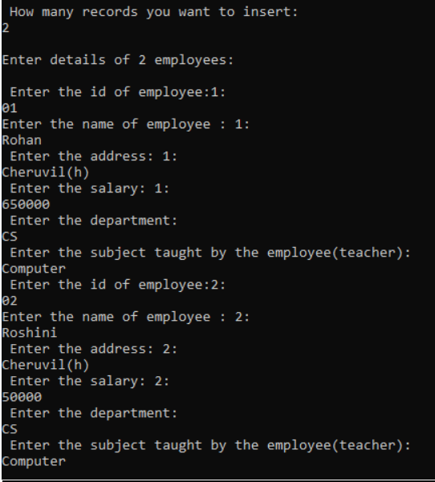

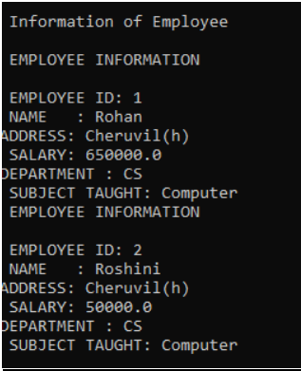

### Result

The program was executed and the result was successfully obtained. Thus CO3 was obtained.

**Experiment No: 11**

**Aim**

Create a class ‘Person’ with data members Name, Gender, Address, Age and a constructor to initialize the data members and another class ‘Employee’ that inherits the properties of class Person and also contains its own data members like Empid, Company_name, Qualification, Salary and its own constructor. Create another class ‘Teacher’ that inherits the properties of class Employee and contains its own data members like Subject, Department, Teacherid and also contain constructors and methods to display the data members. Use array of objects to display details of N teachers.

**CO3**

Implement object-oriented concepts like inheritance, overloading and interfaces

**Procedure**

import java.util.Scanner;

class person

{

String Name;

String Gender;

String Address;

int Age;

person(String name,String gender,String address, int age)

{

this.Name = name;

this.Gender = gender;

this.Address = address;

this.Age = age;

}

}

class Employee extends person

{

int Empid;

String Company_name;

String Qualification;

long Salary;

Employee(String name,String gender,String address, int age,int empid, String company_name, String qualification,long salary)

{

super(name,gender,address,age);

this.Empid= empid;

this.Company_name=company_name;

this.Qualification=qualification;

this.Salary=salary;

}

}

public class Teacher2 extends Employee

{

String Subject;

String Department;

String Teacherid;

Teacher2(String name,String gender,String address, int age,int empid, String company_name, String qualification,long salary, String subject, String department, String teacherid)

{

super(name,gender,address,age,empid,company_name,qualification,salary); this.Subject=subject;

this.Department=department;

this.Teacherid=teacherid;

}

void display()

{

System.out.println("Name: "+Name);

System.out.println("Gender: "+Gender);

System.out.println("Address: "+Address);

System.out.println("Age: "+Age);

System.out.println("Employee id: "+Empid);

System.out.println("Company Name: "+Company_name); System.out.println("Qualification: "+Qualification);

System.out.println("Salary: "+Salary);

System.out.println("Subject: "+Subject);

System.out.println("Department: "+Department);

System.out.println("Teacher id: "+Teacherid);

}

public static void main(String[] args)

{

System.out.println("\nEnter the No.of Teacher's");

Scanner sc1 = new Scanner(System.in);

int num = sc1.nextInt();

Teacher2 arr[]=new Teacher2[num];

System.out.println("\n Enter the Teacher Details\n");

int x =0,j=0;

Scanner sc =new Scanner(System.in);

for(int i=0;i <num;i++)

  {

x = i+1;

  System.out.println("\n"+x+").");

  System.out.println("\n Name: ");

  String a =sc.next();

System.out.println("\n Gender: ");

  String b =sc.next();

  System.out.println("\n Address: ");

  String c =sc.next();

  System.out.println("\n Age: ");

  int d =sc.nextInt();

  System.out.println("\n Employee id: ");

  int e =sc.nextInt();

  System.out.println("\n Company name: ");

  String f =sc.next();

  System.out.println("\n Qualification: ");

  String g =sc.next();

  System.out.println("\n Salary: ");

  long h =sc.nextLong();

  System.out.println("\n Subject: ");

  String k =sc.next();

  System.out.println("\n Department: ");

  String l =sc.next();

  System.out.println("\n Teacher Id: ");

  String n =sc.next();

  arr[i]=new Teacher2(a,b,c,d,e,f,g,h,k,l,n);

  }

  sc.close();

  System.out.println("\n********Informations of all the Teacher's************");

  for(int i=0;i<num;i++)

{

  j=i+1;

  System.out.println("\n"+j+").");

  arr[i].display();

  }

sc1.close();

}

}

**Output Screenshot**

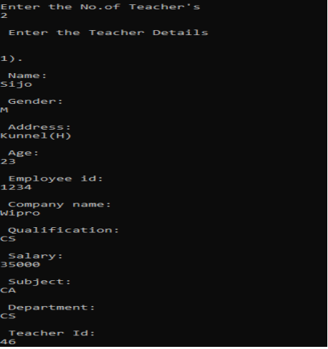

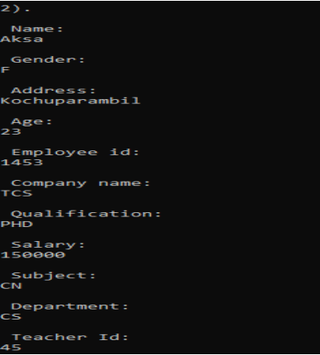

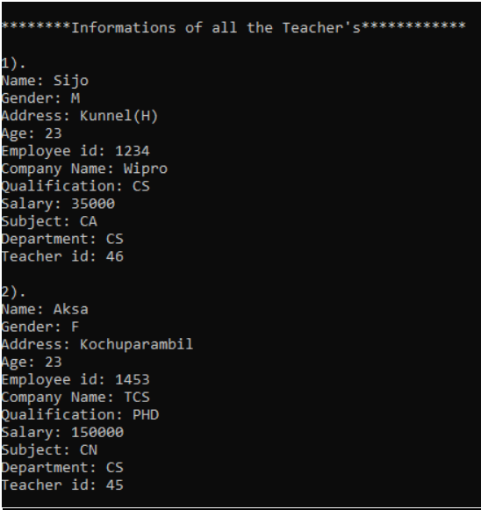

### Result

The program was executed and the result was successfully obtained. Thus CO3 was obtained.

**Experiment No: 12**

**Aim**

Write a program has class Publisher, Book, Literature and Fiction. Read the information and print the details of books from either the category, using inheritance.

**CO3**

Implement object-oriented concepts like inheritance, overloading and interfaces

**Procedure**

import java.util.Scanner;

class Publisher

{

String publisher;

Publisher(String pub)

{

this.publisher=pub;

}

}

class Book extends Publisher

{

String book;

Book(String pub,String boo)

{

super(pub);

book=boo;

}

}

class Literature extends Book

{

String category;

Literature(String pub, String boo)

{

super(pub, boo);

}

void display()

{

System.out.println("Publisher :"+publisher);

System.out.println("Book :"+book);

}

}

class Fiction extends Book

{

Fiction(String pub, String boo)

{

super(pub, boo);

}

void display()

{

System.out.println("Publisher :"+publisher);

System.out.println("Book :"+book);

}

}

public class bookDetails

{

public static void main(String[] args)

{

System.out.println("Enter the No. of Literature Books:");

Scanner sc1 = new Scanner(System.in);

int num = sc1.nextInt();

Literature arr[]=new Literature[num];

System.out.println("\n Enter the Literature Book Details:");

int x = 0,j=0;

Scanner sc =new Scanner(System.in);

for(int i =0;i <num;i++)

  {

 x = i +1;

  System.out.println(""+x+".");

  System.out.println("Book : ");

  String boo =sc.next();

  System.out.println("Publisher: ");

  String pub =sc.next();

  arr[i]=new Literature(boo,pub);

  }

System.out.println("\nEnter the No. of Fiction Books:");

  int num1 = sc1.nextInt();

  Fiction arr1[]=new Fiction[num1];

  System.out.println("\n Enter the Fiction Book Details:");

  int x1 = 0,j1=0;

  for(int i =0;i<num1;i++)

  {

  x1 = i +1;

  System.out.println(""+x1+".");

  System.out.println(" Book : ");

  String boo =sc.next();

  System.out.println(" Publisher: ");

  String pub =sc.next();

  arr1[i]=new Fiction(boo,pub);

  }

  sc.close();

  sc1.close();

  System.out.println("\n--Informations of all the Literature Books--");

  for(int i=0;i<num;i++){

  j=i+1;

  System.out.println("\n"+j+".");

  arr[i].display();

  }

 System.out.println("\n--Informations of all the Fiction Books--");

 for(int i=0;i<num1;i++){

  j1=i+1;

  System.out.println("\n"+j1+".");

  arr1[i].display();

  }

 sc1.close();

}

}

**Output Screenshot**

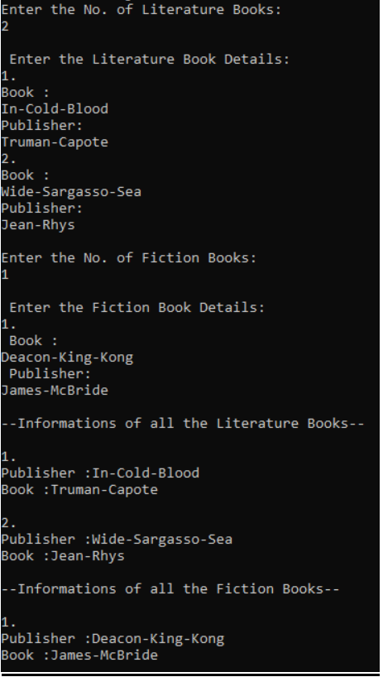

### Result

The program was executed and the result was successfully obtained. Thus CO3 was obtained.

**Experiment No.: 14**

**Aim**

Create classes Student and Sports. Create another class Result inherited from Student and Sports. Display the academic and sports score of a student.

**CO3**

Implement object-oriented concepts like inheritance, overloading and interfaces

**Procedure**

import java.util.*;

import java.io.*;

interface Sports

{

public void sports_getData();

public void sports_dispData();

}

class Student

{

String name;

int roll_no;

float mark1, mark2;

Student(String n, int r, float m1, float m2)

{

name = n;

roll_no = r;

mark1 = m1;

mark2 = m2;

}

void display()

{

System.out.println("Student Details");

System.out.println("Name of Student: " + name);

System.out.println("Roll No. of Student: " + roll_no);

System.out.println("Marks of Subject 1: " + mark1);

System.out.println("Marks of Subject 2: " + mark2);

}

}

class Result extends Student implements Sports

{

int r;

String item;

Scanner sc = new Scanner(System.in);

Result(String n, int r, float m1, float m2)

{

super(n, r, m1, m2);

}

public void academic()

{

float total = (mark1 + mark2);

float percent = total * 100 / 200;

System.out.println("___Academic Info___");

System.out.println("Percentage: " + percent + "%");

}

public void sports_getData()

{

System.out.print("Enter the sports item which student participated : ");

item = sc.nextLine();

System.out.print("Enter the rank position that the obtained : ");

r = sc.nextInt();

}

public void sports_dispData()

{

System.out.println("____sports Info____");

System.out.println("Item :" + item);

System.out.println("Rank :" + r);

}

}

class SportsResult

{

public static void main(String args[]) throws IOException

{

InputStreamReader isr = new InputStreamReader(System.in);

BufferedReader br = new BufferedReader(isr);

System.out.print("Enter the name : ");

String n = br.readLine();

System.out.print("Enter roll no : ");

int roll = Integer.parseInt(br.readLine());

System.out.print("Enter mark in first subject : ");

float m1 = Float.parseFloat(br.readLine());

System.out.print("Enter mark in second subject : ");

float m2 = Float.parseFloat(br.readLine());

Result re = new Result(n, roll, m1, m2);

re.sports_getData();

re.display();

re.academic();

re.sports_dispData();

}

}

**Output Screenshot**

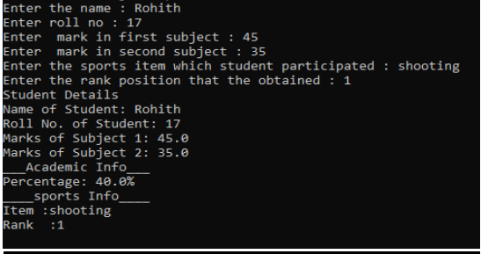

### Result

The program was executed and the result was successfully obtained. Thus CO3 was obtained.

### Experiment No: 14

**Aim**

Create an interface having prototypes of functions area() and perimeter(). Create two classes Circle and Rectangle which implements the above interface. Create a menu driven program to find area and perimeter of objects.

**CO3**

Implement object-oriented concepts like inheritance, overloading and interfaces

**Procedure**

import java.util.Scanner;

interface prop

{

void getdata();

void area();

void perimeter();

}

class Circle implements prop

{

double pi = 3.14;

double r;

Scanner sc = new Scanner(System.in);

public void getdata()

{

System.out.println("Enter the radius of the circle:");

r = sc.nextDouble();

}

public void perimeter()

{

System.out.println("Perimeter of the circle: "+(2*pi*r));

}

public void area()

{

System.out.println("Perimeter of the circle: "+(pi*r*r));

}

}

class Rectangle implements prop

{

double l,b;

Scanner sc = new Scanner(System.in);

public void getdata()

{

System.out.println("Enter the length of the rectangle:");

l = sc.nextDouble();

System.out.println("Enter the breadth of the rectangle:");

b = sc.nextDouble();

}

public void area()

{

System.out.println("Area of a rectangle: "+(l*b));

}

public void perimeter()

{

System.out.println("Perimeter of a rectangle: "+(2*(l+b)));

}

}

public class CO3Q6

{

public static void main(String[] args)

{

int ch,u=0; Scanner sc = new Scanner(System.in);

Circle ob = new Circle();

Rectangle obj = new Rectangle();

do

{

System.out.println("\n1.Circle\n2.Rectangle\n3.exit"); System.out.println("Enter your choice:");

ch = sc.nextInt();

switch(ch)

{

case 1 :ob.getdata();

ob.area();

ob.perimeter();

break;

case 2 :obj.getdata();

obj.area();

obj.perimeter();

break;

case 3 :System.out.println("Exited");

System.exit(0);

}

}while(u==0);

}

}

**Output Screenshot**

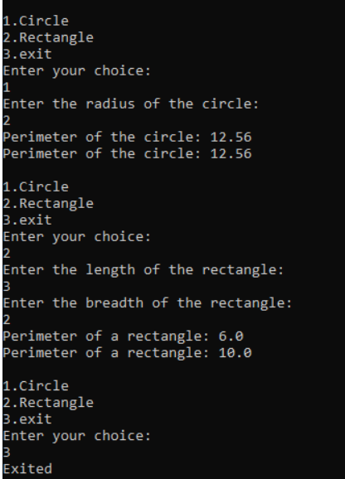

### Result

The program was executed and the result was successfully obtained. Thus CO3 was obtained.

**Experiment No: 15**

**Aim**

Prepare bill with the given format using calculate method from interface.

Order No.

Product Id Name Quantity unit price Total

101 A 2 25 50

102 B 1 100 100

Net. Amount 150

**CO3**

Implement object-oriented concepts like inheritance, overloading and interfaces

**Procedure**

import java.util.Scanner;

interface calc

{

void calculate();

}

class bill implements calc

{

String date,name,p_id;

int quantity;

double unit_price,total,namount=0;

Scanner sc = new Scanner(System.in);

public void getdata()

{

System.out.println("\nEnter product id:");

p_id = sc.nextLine();

System.out.println("Enter product name:");

name = sc.nextLine();

System.out.println("Enter the Quantity:");

quantity = sc.nextInt();

System.out.println("Enter the unit price:");

unit_price = sc.nextDouble();

}

public void calculate()

{

total = quantity * unit_price;

}

public void display()

{

System.out.println(p_id+"\t\t"+name+"\t\t"+quantity+"\t\t"+unit_price+"\t"+total); }

}

public class CO3Q7

{

public static void main(String[] args)

{

int n,i;

double namount=0,t;

int ran;

String date;

t = Math.random() *1000000;

ran = (int) t;

Scanner sc = new Scanner(System.in);

System.out.println("Order no. #"+ran);

System.out.println("Enter the date:");

date = sc.nextLine();

System.out.println("Enter how many products are there:");

n = sc.nextInt();

bill ob[] = new bill[n];

for(i=0;i <n;i++)

{

  ob[i].getdata();

 ob[i].calculate();

  }

  System.out.println("Date:"+date);

  System.out.println("Product Id Name Quantity unit price Total ");

  System.out.println("--------------------------------------------------------------");

for(i=0;i<n;i++)

{

  ob[i].display();

  namount += ob[i].total;

 }

  System.out.println("--------------------------------------------------------------");

  System.out.println("\t\t\t\tNet.Amount\t\t"+ namount);

 }

}

**Output Screenshot**

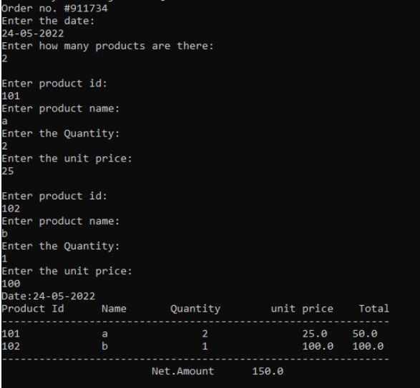

### Result

The program was executed and the result was successfully obtained. Thus CO3 was obtained.

**Experiment No: 17**

**Aim**

Create a Graphics package that has classes and interfaces for figures Rectangle, Triangle, Square and Circle. Test the package by finding the area of these figures.

**CO4**

Implement packages, exception handling, multithreading and generic programming by using the java.util package and Collection framework.

**Procedure**

**Graphics package**

import package_graphics.*;

import java.util.*;

public class main_graphics

{

public static void main(String []args)

{

package_graphics testObj = new package_graphics();

int l,h,r,a,c,d; Scanner s=new Scanner(System.in);

System.out.println("Enter the length for rectangle");

l=s.nextInt();

System.out.println("Enter the breadth for rectangle");

h=s.nextInt();

System.out.println("Enter the radius of circle");

r=s.nextInt();

System.out.println("Enter the side for Square");

a=s.nextInt();

System.out.println("Enter the breadth for triangle");

c=s.nextInt();

System.out.println("Enter the height for triangle");

d=s.nextInt();

System.out.println("area of rectangle:"+testObj.recArea(l,h)); System.out.println("area of circle :"+testObj.cirArea(r));

System.out.println("area of square:"+testObj.squArea(a));

System.out.println("area of triangle"+testObj.triArea(c,d));

}

}

**Interface**

package package_graphics;

interface interface_graphics

{

public float recArea(int l, int h);

public float cirArea(int r);

public float squArea(int a);

public float triArea(int l, int h);

}

public class package_graphics implements interface_graphics

{

public float recArea(int l, int h)

{

return l*h;

}

public float cirArea(int r)

{

return r*r*(float)3.14;

}

public float squArea(int a)

{

return a*a;

}

public float triArea(int l, int h)

{

return l*h*(float)(.5);

}

}

**Output Screenshot**

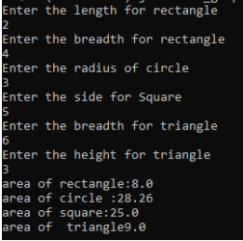

### Result

The program was executed and the result was successfully obtained. Thus CO4 was obtained.

**Experiment No: 18**

**Aim**

Create a Graphics package that has classes and interfaces for figures Rectangle, Triangle, Square and Circle. Test the package by finding the area of these figures.

**CO4**

Implement packages, exception handling, multithreading and generic programming by using the java.util package and Collection framework.

**Procedure**

**Graphics package**

import package_graphics.*;

import java.util.*;

public class main_graphics

{

public static void main(String []args)

{

package_graphics testObj = new package_graphics();

int l,h,r,a,c,d; Scanner s=new Scanner(System.in);

System.out.println("Enter the length for rectangle");

l=s.nextInt();

System.out.println("Enter the breadth for rectangle");

h=s.nextInt();

System.out.println("Enter the radius of circle");

r=s.nextInt();

System.out.println("Enter the side for Square");

a=s.nextInt();

System.out.println("Enter the breadth for triangle");

c=s.nextInt();

System.out.println("Enter the height for triangle");

d=s.nextInt();

System.out.println("area of rectangle:"+testObj.recArea(l,h)); System.out.println("area of circle :"+testObj.cirArea(r));

System.out.println("area of square:"+testObj.squArea(a));

System.out.println("area of triangle"+testObj.triArea(c,d));

}

}

**Interface**

package package_graphics;

interface interface_graphics

{

public float recArea(int l, int h);

public float cirArea(int r);

public float squArea(int a);

public float triArea(int l, int h);

}

public class package_graphics implements interface_graphics

{

public float recArea(int l, int h)

{

return l*h;

}

public float cirArea(int r)

{

return r*r*(float)3.14;

}

public float squArea(int a)

{

return a*a;

}

public float triArea(int l, int h)

{

return l*h*(float)(.5);

}

}

**Output Screenshot**



### Result

The program was executed and the result was successfully obtained. Thus CO4 was obtained